Directions for the Using the Commit School Board Goal Setting Resources
DRAFT
The Board Goal Setting Process is part of an on-going cycle of listening to community input, setting goals, developing strategies to meet those goals, and assessing progress towards the goals.
This document and the Commit site will zoom in to the “Use Commit Data Tools” step in the process. This document will give you directions on how to interact with the website dashboards and the data template to result in increased knowledge of your district’s data, as well as the documentation you need to submit to TEA to fulfill the Board Goal Setting Requirement.
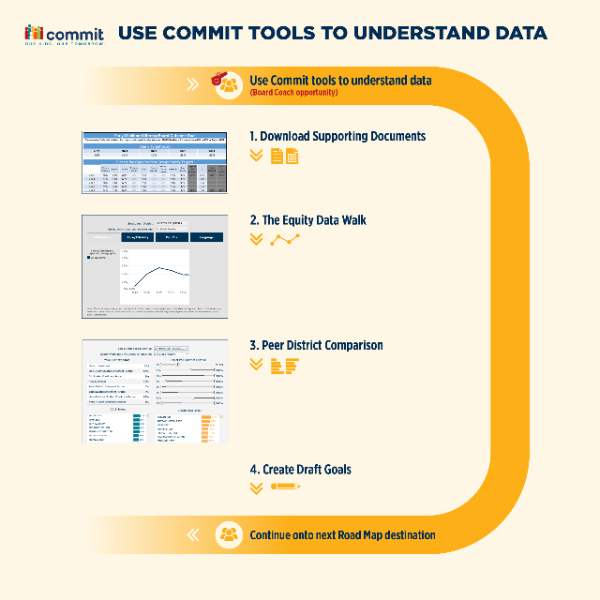
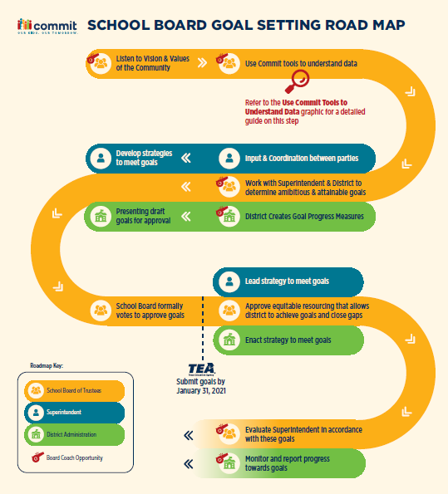

Step 1: Download the Data Template
The Data Template will be like a worksheet that you fill out with your data. You will use it in tandem with the dashboards on the Commit site. You will fill in any cells that have orange borders. Cells that are greyed-out will be automatically populated with data as you fill in the rest of the data template. Therefore, please do not enter any text or data in the grey cells, or any area that is not outlined in orange.
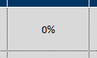
Cells you will fill in: Cells that will automatically fill in:

Because of the number of formulas in the Data Template, it is a delicate document. It is possible for a user to “break” the formulas if they type in the wrong area. We recommend saving your progress frequently in case something goes awry.
Steps:
- Download the Data Template from Step 1 of the website and save it to a safe location on your computer.

Step 2: The Equity Data Walk
TEA requires that boards set goals for all demographic subpopulations for which data is available, which you will see listed out in the data template. The Equity Data Tool in Step 2 of the website will help walk you through the historical data by subpopulation to allow you to dive into the achievement trends and gaps, to give you the context needed to set ambitious, achievable, and equitable goals.
Steps:
- Set Up: Pull up the Commit School Board Goal Setting Resource website and scroll to Step 2. Using the drop downs, select your district and which metric you would like to focus on. Start on the “Step 2” tab of your Data Template and save it to your computer.

- Input Data: In the dashboard, start on the “All Students” tab. You will use the dashboard to see what percent of 3rd graders were reading proficiently at the “Meets Grade Level Standard” in 2015, and 5 years later in 2019.
    - Past (Column C): You will find this number at the beginning of the line on the Equity Walk dashboard.
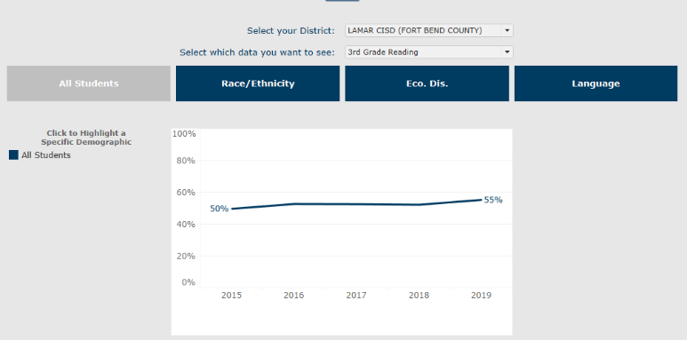
    - Present (Column D): You will find this number at the end of the line on the Equity Walk dashboard.

- Enter this information into the Data Template in the designated cells in Column C and D. The data template will automatically calculate the grey cells in Columns E and F. We will revisit this data during a later step in the process.

- Repeat for All Demographics: Using navy-blue buttons to navigate to other tabs, you will repeat this process in for all your district’s primary demographic groups. For each groups, fill out the template Columns C and D like you did for the other demographics above.
  - Note: If your district does not have a significant population of any of these demographics in a given year (5 test takers or more), the data will be hidden due to FERPA requirements.
- Reflect: The Dashboard and the Data Template will help you automatically fill in the data, but now is the time for you to reflect on the data.
  - For this section, you will reference both the data you inputted into Columns C & D, and the automatically populated data in Columns E & F.
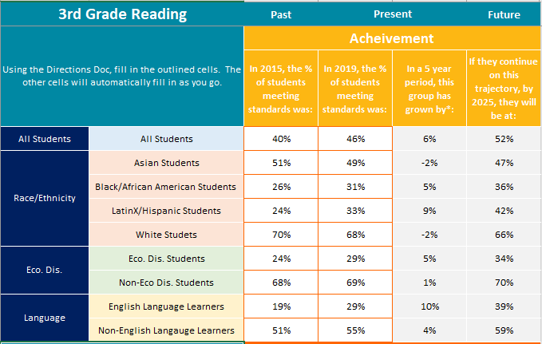

Reflection Questions:
- Which groups have grown the most? Knowing your school community and the programs and resources available to your students, why do you think that is?
- Which groups (if any) have shown negative growth or stagnated? Why might that be? What could be done to change that? Who could you talk to find out more?
For the next portion of the reflection, please scroll down on your Data Template to the Gaps section.
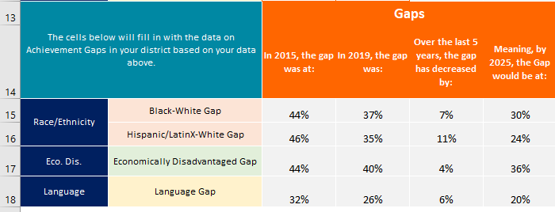

An Important Note on “Achievement Gaps” The gaps portion of this exercise is meant to help highlight, and close, historic achievement gaps. Therefore, gaps are calculated relative to the historically advantaged groups.
However, it is extremely important to note that behind every achievement gap, there is often an Opportunity Gap where some students were historically given access to resources that another group was not. This exercise it meant to help you analyze your Achievement Gaps, and then dig deeper into what Opportunity Gaps might exist in your district to cause such disparities.
Reflection Questions:
  - What gaps are getting smaller in your district? Are any getting larger? What policies or resourcing decisions might be contributing to that?
  - What did you learn from this data?

Step 3: Peer District Comparison*
A “Peer District” is another Texas public school district with a similar size and demographic composition to yours. Peer Districts are helpful during the goal-setting process because they help you determine what goals are realistic for your students, given the current achievement. Using this tool, you will be able to dynamically determine your peer district group and get a sense of what type of achievement and growth has been historically possible for districts like yours.
Steps:
- Set Up: Open the Data Template and Website to Step 3.
  - On the Data Template Step 3 & 4 tab, type in your 6-digit TEA district ID into cell B3. This will populate the data to help you along the way.
    - If you need to look up your district ID, you can use the dropdown on the main Commit Dashboard:
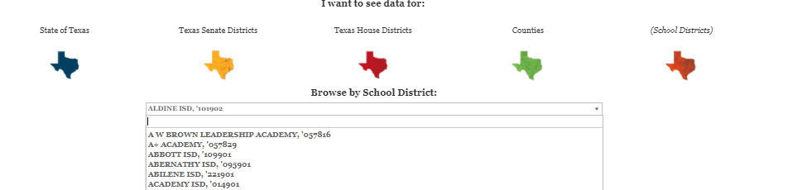

  - On the Peer Comparison Dashboard, select your district and metric from the drop down. The demographic information for your district will automatically populate below.
- Peer District Selection: Once you have selected your district from the dropdown, you will see your demographics appear on the left. You will then use the sliders on the right to narrow your peer districts.
  - Using the Sliders: For each of the available demographics, you can use the slider to narrow down the range for your peer districts. If the filters are set to the max and min values, all public districts in Texas will be displayed as part of your peer group. Your goal is to narrow the criteria down so that you feel comfortable comparing yourself to all districts.

- Identify Highest Achieving Peer District: Using the teal graph on the bottom left, identify the highest performing district that you feel comfortable identifying or comparing yourself with as if your district. Record that districts name and its scores in columns F and G. This data point will serve as context for setting your goals, and the district will serve as a potential resource for peer collaboration.
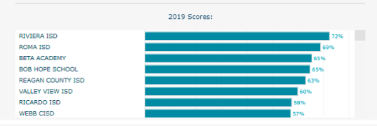
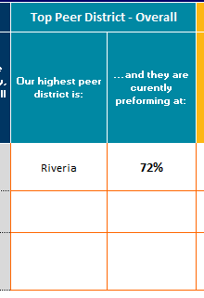

- Identify Highest Growth Peer District:
Next, use the yellow graph on the bottom right to identify the Peer District with the highest 5-year growth. (This district may or may not be the same as the district you identified in the previous step.) Enter the name of that high growth district and their data into columns H and I. This data point will help give you context of what type of year to year growth is ambitious but achievable and the district will serve as a potential source of peer to peer collaboration to learn about how their district was able to grow at such a fast rate.
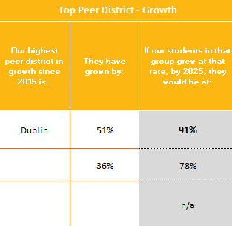
Column J will automatically populate with data.
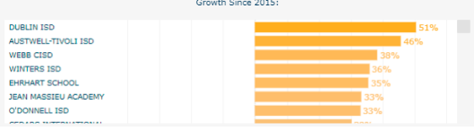

Step 4: Create Draft Goals
Due to the data interdependencies, you can only manipulate 2 pieces of data: A. The goal for All Students, and B. The rate at which you would like to close equity gaps. Therefore, you cannot directly edit the goals for multiple populations without breaking the formulas. However, you can always use the templates as a guide, and edit accordingly with your Board Coach or Academic Accountability Department.
Steps:
- Drafting Your 5-Year Goal: Using the context you gathered in the previous step and the equity walk, determine what an ambitious, but attainable goal would be for your district. Columns E, G, and J should represent a spectrum of potential goals, but ultimately, this is a subjective decision. There is no right answer. You want to set a goal that is ambitious, but also achievable for your district. Enter your draft goal into Column K.
- Closing the Gap: Once you have decided on a draft goal and entered it into Column K, you will see a “50%” in Column L. This value represents the rate at which you would like to shrink achievement gaps. You can use the default of 50%, or for more savvy data users, you can edit the value to any number between 0 and 100.
(Ex: A value of 0% tells the calculator to leave your gaps between students at their current size. A value of 100% would set goals to close the gap aggressively and completely over the next 5 years, but might also mean that some students are not expected not grow at all.)
- Critical Thinking-Are these goals ambitious and attainable?
- Once you have filled out steps 2-4, your TEA template for the given metric will automatically be populated with recommended goals on the corresponding tab. It should look something like this:
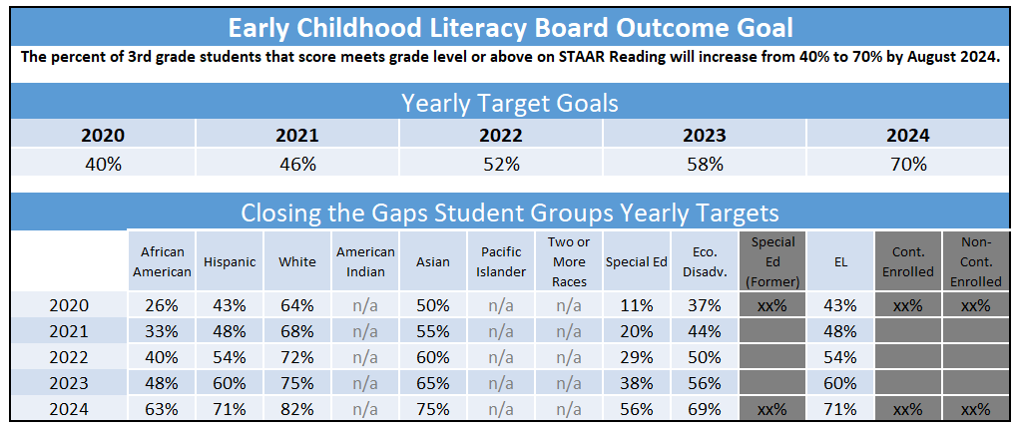

Note: Grey Cells: The greyed-out cells represent data that is not publicly available. Please work with your district to get these values.
- This is the most important step in the entire process. Review your recommended goals and for each demographic and year, ask yourself, “Is this goal ambitious and attainable?”
  - If the answer to either of these questions is no, revisit and adjust the values from the previous two steps.
  - Alternatively, if you would like to make tweaks to your recommended goals, copy/paste and save your template into another excel document. From there, you can make changes to your recommended goals without worrying about the formulas in the Data Template.
- Once you are satisfied with your template, save your document.

- Repeat the Process: Once you have finalized your template 3rd grade reading, you will repeat the process for other two metrics 3rd Grade Math, and College and Career Readiness.

**Campus-Level Goals: Once you have completed your Data Template with your District-level goals for all 3 metrics, please email marie.appel@commitpartnership.org. Once we verify your template, we will combine your district goal and campus data to create a custom campus-level goal calculator.

